Roy’s last shot
IS A PROUD SPONSOR OF
The Philip K. Dick Festival
Colorado 2010 – August 13, 14 & 15th
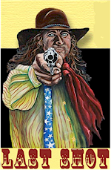  303-642-7870 | 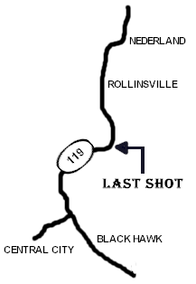 | 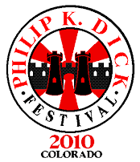  www.philipkdickfestival.com

Denver Post , June 26 2010:
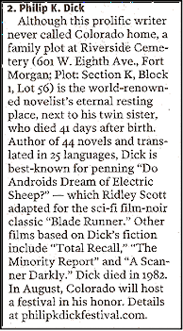
PKD Festival Events start 10:00am on Friday August 13th at
THE LAST SHOT on Hwy 119 just north of Black Hawk
Music ¤ Food ¤ Speakers¤ Conference ¤ Art ¤ Charity Auction¤ Fun!
FRIDAY NIGHT PARTY WITH LOCAL BANDS!
Come to THE LAND OF SMILES and celebrate this great American Science Fiction writer!

